Link for UTM Transport System Questionaire : UTM Transport System Questionaire

Questionnaire questions:
Question 1:


Question 2:
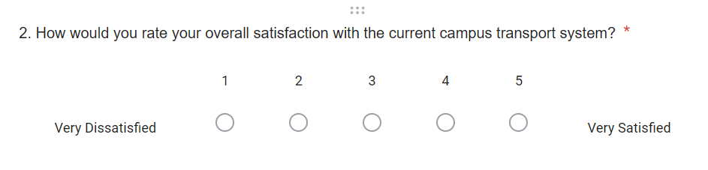

Question 3:
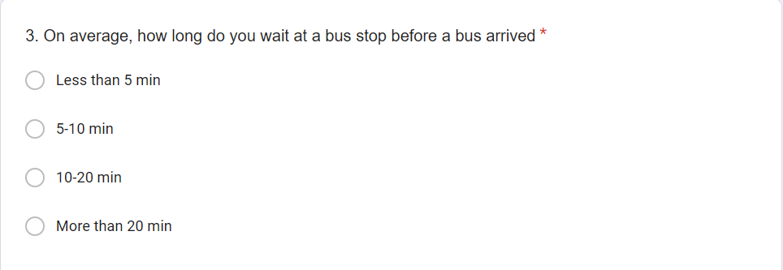

Question 4:
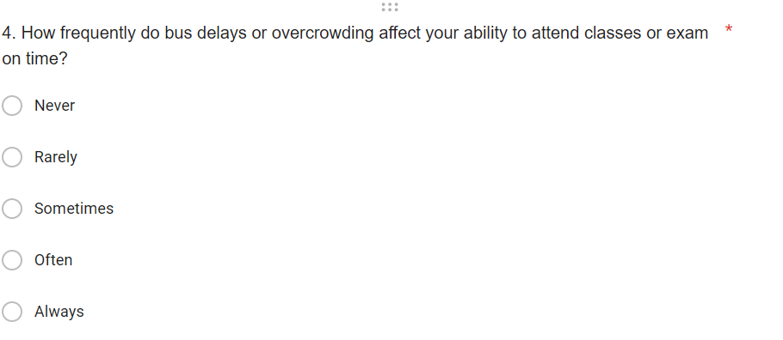

Question 5:
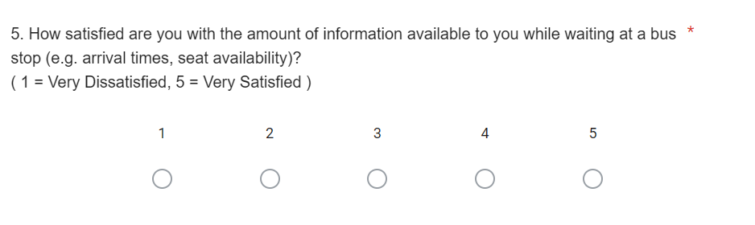

Question 6:
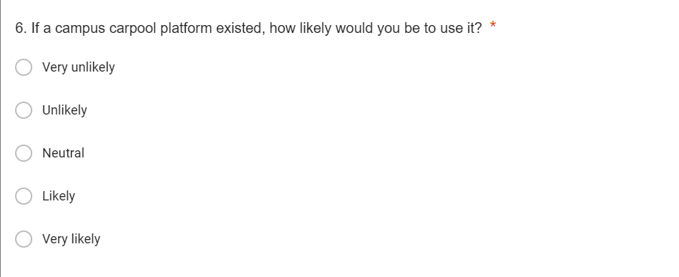

Question 7:
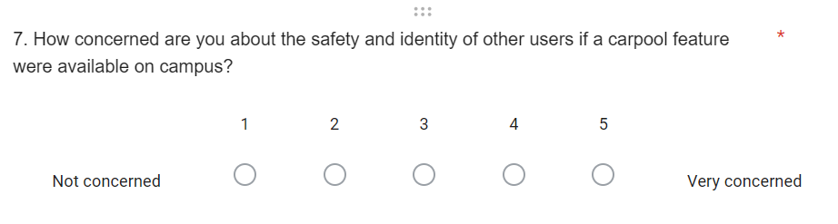

Question 8:
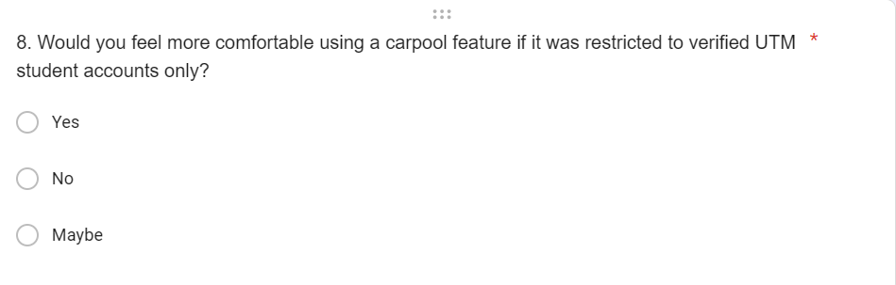

Question 9: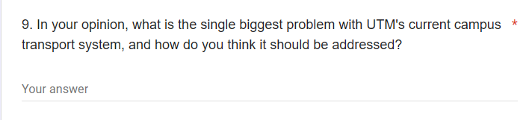

Question 10:


